www.myfreewilljourney.com
https://www.facebook.com/MyFreewillJourney/

Paris Yves Read
Holistic Counsellor, Clairvoyant, Medium, Bird Behaviourist
Melbourne Australia 0061-(0)413 530 419

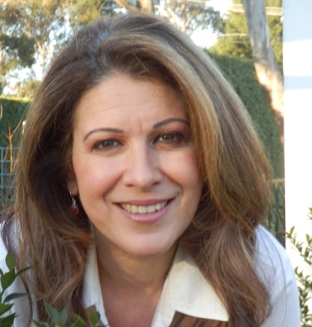
Hello!
Thank you for considering me to help guide you with aspects of your life, so you can gain further clarity and resolve any problems!
You can request from me either a Counselling, Clairvoyant or Medium session or all of these combined!

Please complete details below:
Confidential Client Information and Consent Form

Appointment Details include:

- No Fee for your initial 5-10 minutes enquiry chat (by phone) to determine if I can help you and if you are happy to proceed with an appointment.

- I research specific and/or personalised information for you to help you with your setbacks and to help you move forward in your life, feeling confident and assertive.

- I send you personalised information to be emailed to you during or after each appointment, to help you further work on your setbacks/problems, with or without me guiding you further. You are not obligated to continue sessions with me- it is your choice!

- Appointment times can vary- approximately 60 minutes, or more time if you require- please request the length of time you prefer before appointment booking.

- If you need to cancel/reschedule our appointment, kindly let me know 24 hrs prior. Deposit fully refunded to you.

- $150 per 60 minute consultation via skype, facebook video messenger. I kindly request a $50 appointment booking deposit prior to appointment. Please email me confirmation of transfer via myfreewilljourney@hotmail.com – thank you!

If you are unemployed or cannot afford the fee, I still want to help you. Helping people is my life passion. Any amount you can afford to contribute is much appreciated. I will not judge or refuse to help people because of your financial circumstances.

  - Account details: Commonwealth Bank

Name: Paris Yves Read
BSB: 06 26 92
Account no: 38 05 05 44

Your Name:
Address:
Suburb: State: Post Code:
Home Phone:
Mobile:
Email:
Date of Birth: Time of birth: (for optional basic natal western astrological or Feng Shui chart)

Occupation:

Are you a pensioner, unemployed, health benefit etc.?

Is there anything you wish to add here about your life or health to help me help you more?

How did you find me or who referred you? (Please circle answer)
Google Search Internet Listing Advert Friend/Colleague Doctor/ GP
Counsellor/Therapist Other
If you were referred by your Doctor or therapist, do you give me permission, ONLY AFTER I ASK YOU FIRST, to communicate with them about our work together if required? (Please circle answer) Yes No
If YES, please provide GP or therapist practice location and phone number:

Would you like to subscribe to my free email newsletters at MyFreewillJourney.com to receive information, tips and the latest research on relationships? (I will never share your email and you may unsubscribe at any time) Yes No

Your Emergency Contact:
Name:
Relationship to you:
Address:
Home Phone: Mobile:

In an emergency, I agree to allow Paris Yves Read to call the above person/s to inform them of my condition and the need for assistance.

I also agree to have emergency assistance provided by an outside agency if

necessary, e.g. ambulance. Yes No
I have read and understand all of the information stated above regarding
my sessions and agree to all the terms and conditions described in this document.

Your Name:

Signed:

Date:

Now something about me (Paris Yves Read) to you!
My aim is to:

• Treat you with honesty and respect, compassion and empathy.

• Explain and clarify therapy appointments whether by phone, email, skype facebook video messenger.

• Counselling fees are not reimbursed by private health funds or Medicare.

• I am happy to discuss with you how you feel with me helping you and if you feel satisfied with the progress of our discussions.
Please be honest with me about how are discussions are going, how you feel and feel free to suggest to me if there are any ways in my tone or method I can be more helpful to you.
- If you are unemployed or cannot afford the fee, I still want to help you. Helping people is my life passion. Any amount you can afford to contribute is much appreciated. I will not judge or refuse to help people because of your financial circumstances.

- Please provide me with 24hrs notice via phone message or text if you need to cancel/postpone our appointment- if you are suddenly ill or stuck with a major problem, then I will understand- life stuff happen. Full deposit refund provided to you.

Confidentiality:
- I take your privacy seriously.
- All information disclosed within your sessions remain strictly confidential, unless, you give me written permission to speak to another health professional.
- I am required to disclose by the law if I believe that you are at risk of harming yourself or others.
- Current child abuse is reportable by law.

Thank you for taking the time to complete the details above!
Wishing you a wonderful day!

Me & My Parrot Family

